http://www.nsauditor.comNsasoft llc.
MsRPC Audit

Audit MSRPC, is a Microsoft implementation of DCE RPC. The auditor dump is a list of named pipes that are used by Windows RPC services as endpoints. The interface identifier associated with each named pipe represents the service typically accessed when a given named pipe is used.
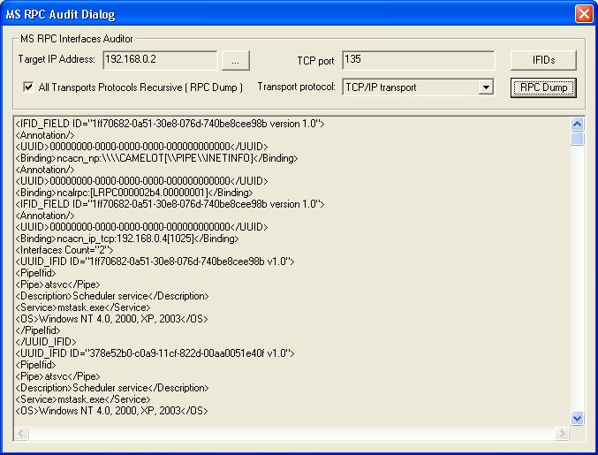

Enter the Target IP Address by clicking on the Browse button and select the Transport Protocol from the combobox.
This tool supports the following protocol types TCP/IP transport, UDP/IP transport, SMB named pipe transport, Local RPC transport, HTTP transport.
Click on the button IDIDs to dump information for the specified TCP port.
To dump information about all available ports select All Transports Protocols Recursive and click on the button RPC Dump.

