http://www.nsauditor.comNsasoft llc.
MsSql Audit

MsSql Audit consists of 2 parts: MS SQL Server Pinger and MS SQL Server Auditor.
To verify that the MS SQL server exists enter SQL Server IP address and click on the button Ping SQL. You should also specify the Timeout interval to wait for the responses from the server. 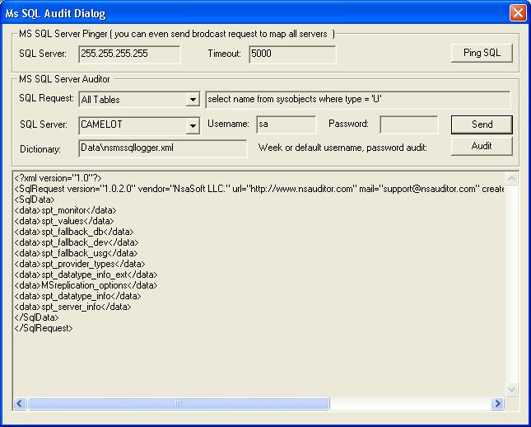

Before starting auditing process, you should send the SQL request to MS SQL server. To configure the request enter the SQL Request, select the SQL Server name, enter the Username and Password. Click on the button Send to send the request . The specified Username and password will be used as SQL Server login parameters.
To start auditing weak password using the specified xml database click on the Audit button.
We can add or remove the usernames and passwords by editing nsmssqllogger.xml.
The specified XML file consists of 2 parts : Logins and Passwords, containing login names list and passwords list accordingly.

