http://www.nsauditor.comNsasoft llc.
SunRpc Audit

SunRpc Auditor is a tool to examine Remote Procedure Call (RPC ) services for vulnerabilities. An audit that looks for the existence of a vulnerable rpc server running on a remote computer will fall under this section.
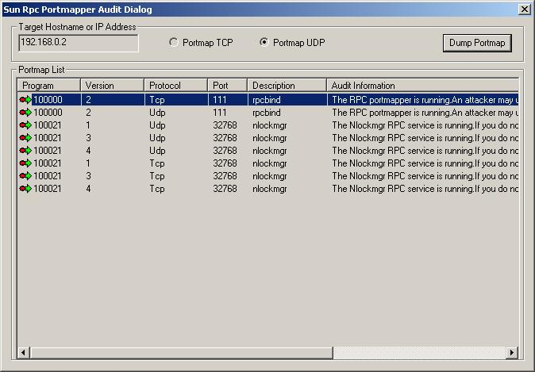

This tool allows you to dump a portmap in the Pormap List.
The portmap list contains the following fields:
Program ( the program name using the port ), Version, Protocol ( the protocol name ),
Port ( port number), Description ( port description ) , Audit Information.
To start audit enter the Target Hostname or IP Address and click on the Dump Portmap button. You should also specify the protocol type ( Portmap TCP or Portmap UDP).

