http://www.nsauditor.comNsasoft llc.
UDP Statistics

UDP Statistics provides an information about UDP datagrams. The UDP statistics dialog shows the details about UDP datagrams the number of received datagrams, datagrams without port, datagrams with errors, sent datagrams, listening connections.

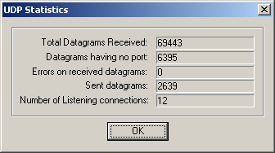

All fields are updated automatically for each received UDP datagram.

