http://www.nsauditor.comNsasoft llc.
Web Log Analyzer

Web LogAnalyzer parses the default file access.log which is written by Apache Web-server, converts it to XML document and analyzes the output XML file.

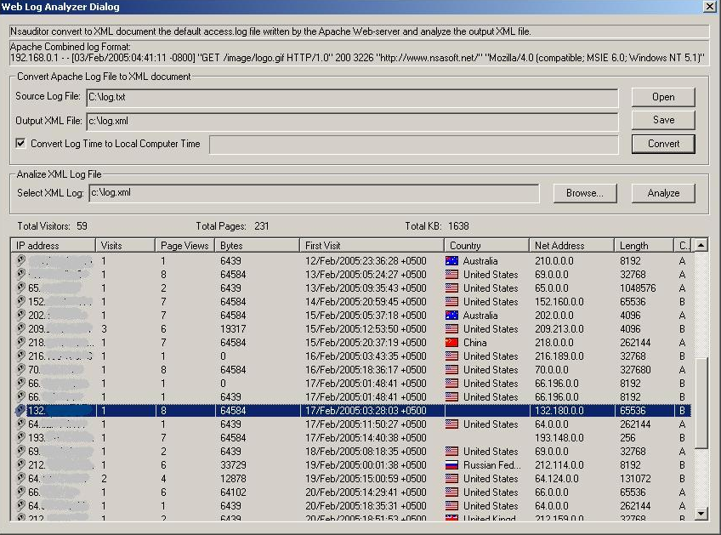

To convert the apache log file to XML document you should open the Source Log File
and select the Output XML file. To convert the selected file click on the button Convert.
To start analyzing process Select XML Log and click on the button Analyze. The list control will contain the following information;
IP address, Visits, Page Views, Bytes, First Visit, Country, Net Address, Length, etc.
Also Toltal Visitors, Total Pages , and Total Size will be available.

