http://www.nsauditor.comNsasoft llc.
Dns Lookup

DNS lookup is a tool to convert IP addresses to hostnames and vice versa and to obtain aliases. DNS lookup performs advanced DNS queries, such as MX or CNAME. The full list of queries supported by this tool contains A, NS, MD, MF, CNAME, SOA, MB, MG, MR, NULL, WKS, PTR, HINFO, MINFO,MX,TXT,AXFR,MAILB,MAILA,*.
To perform a standard query, select Standard Mode from the Question Type list, enter an IP address or hostname in the Dns Servers field, and click Resolve. The program will display the query result in a few seconds.
To perform non-standard queries, select the type of record you are requesting from the Question Type list, enter your query in the Dns Query field, and enter a DNS server address in the Dns servers field, and click Resolve. The program will display the query results in few seconds in Dns Response section.

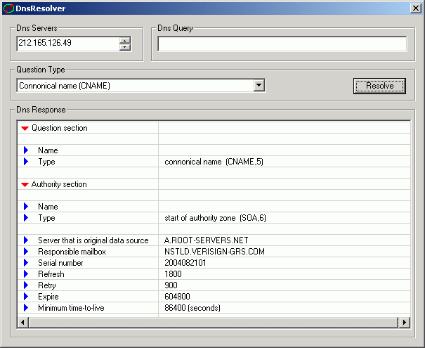
Using Dns tools makes possible to check if the host is a Real-time Black list for spammers “RBL “.
To use this feature select the appropriate IP address in “Connection Monitoring” view and select from right click pop-up menu the item “RBL Check…”.
To create your own request use the algorithm described bellow:
To check if 127.0.0.2 IP address is in SORBS Real-time Black list , select “Host Address (A)” from Question type combo box type in “Dns Query” box the IP address in reverse order.For “127.0.0.2” you will get “.dnsbl.sorbs.net”.
The result will be “2.0.0.127.dnsbl.sorbs.net” .
This tool requests following DNS records for a host or domain

A a host address
NS an authoritative name server
MD a mail destination (Obsolete - use MX)
MF a mail forwarder (Obsolete - use MX)
CNAME the canonical name for an alias
SOA marks the start of a zone of authority
MB a mailbox domain name (EXPERIMENTAL)
MG a mail group member (EXPERIMENTAL)
MR a mail rename domain name (EXPERIMENTAL)
NULL a null RR (EXPERIMENTAL)
WKS a well known service description
PTR a domain name pointer
HINFO host information
MINFO mailbox or mail list information
MX mail exchange
TXT text strings
AXFR A request for a transfer of an entire zone
MAILB A request for mailbox-related records (MB, MG or MR)
MAILA A request for mail agent RRs (Obsolete - see MX)
ALL A request for all records

