http://www.nsauditor.comNsasoft llc.
Whois

Whois Tool is a client utility that communicates with WHOIS servers located around the world to obtain domain registration information. Whois supports IP address queries and automatically selects the appropriate whois server for IP addresses.This tool will lookup information on a domain, IP address, or a domain registration information . You can select a specific WhoIs Server,

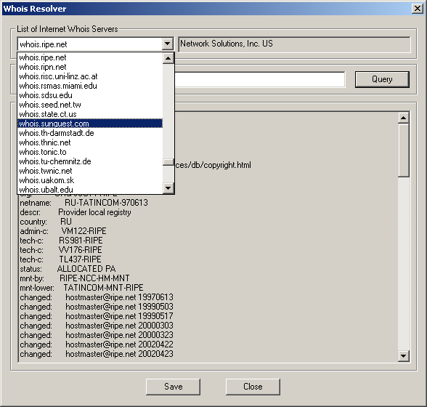

or you can use the 'Default' option which will select a server for you.
To start the process enter the query in the Whois Query field and click on the Query button. The response will be received in the Whois Reponse field. To save the results in the text file click on the Save button. Clicking on the Close button will close the dialog.
