http://www.nsauditor.comNsasoft llc.

Edit Packet

Packet editor is a tool which allows to edit a filtered packet header. To filter a packet select Packet Filter in Sessions tab. After setting appropriate settings of a packet to filter you can start filtering process by clicking on the button Start. The packets with the specified parameters will appear in the screen. Right clicking on the row brings up a pop-up menu with the following commands:
Edit Packet – opens Packet Editor dialog.
Save As – saves the data to the text file.
Copy All - copies all rows.

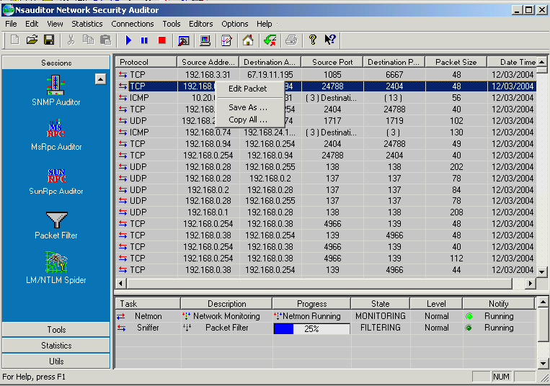

Packet editor is an editor that allows you to view the decoded packet and edit the packet header and data.
Right clicking on the bottom of the window brings up the pop up menu with the following commands:

Select All - selects all packet data.
Save As – saves the data to the selected file.
Copy – copies the selected part to the clipboard.
Past - pasts from the clipboard.
Past From File - pasts data from the selected file.
Close - closes the dialog.
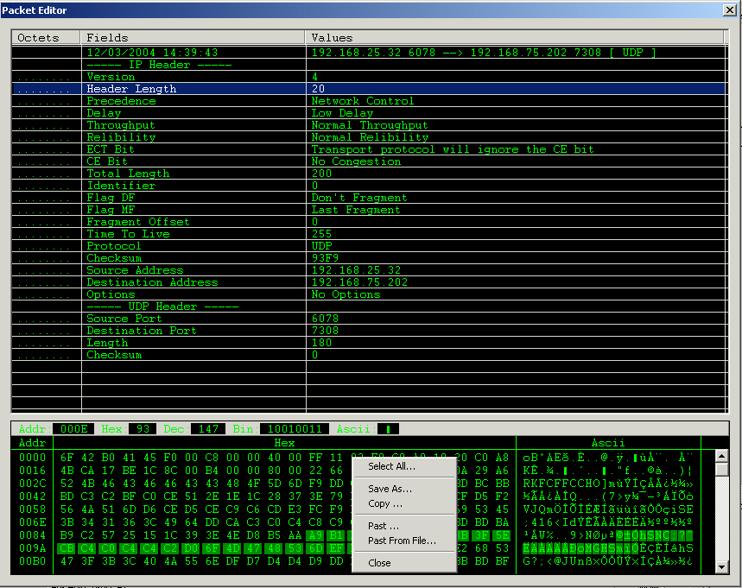

Packet editor is a very useful tool in packet analyzing. It has a user-friendly interface and is designed for easy use.

