http://www.nsauditor.comNsasoft llc.
Process Monitoring

Process monitoring is a tool to monitor the system process information. This dialog contains the list of process( applications and services ) currently running on a local computer.

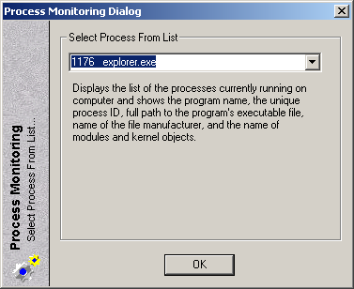

To monitor the process information select the process name form the list. The Process Details dialog will appear in the screen.

